Name : Hrujuta Gitay
Roll no.: 65
Class : BE B ENTC

Code:

<!DOCTYPE html>
<html lang="en">
<head>
<meta charset="UTF-8">
<meta name="viewport" content="width=device-width, initial-scale=1.0">
<title>Digital Clock</title>
<style> body { display: flex; justify-content: center; align-items: center; height: 100vh;
background: linear-gradient(135deg, #2c3e50, #4ca1af); color: white;
font-family: 'Poppins', sans-serif; margin: 0;
}

.clock {
background-color: rgba(0, 0, 0, 0.3); padding: 30px 60px; border-radius: 15px;
box-shadow: 0px 4px 10px rgba(0, 0, 0, 0.5);
font-size: 48px; letter-spacing: 2px;
text-align: center;
}

h2 { text-align: center; margin-bottom: 20px; font-size: 28px;
color: #f1f1f1;
}
</style>
</head>
<body>
<div>
<h2>꽎꽐꽇꽑꽏 Digital Clock</h2>
<div class="clock" id="clock">00:00:00</div>
</div>

<script> function updateClock() { const now = new Date();
let hours = now.getHours(); let minutes = now.getMinutes(); let seconds = now.getSeconds();

// Add leading zeros
hours = hours < 10 ? "0" + hours : hours; minutes = minutes < 10 ? "0" + minutes : minutes;
seconds = seconds < 10 ? "0" + seconds : seconds;

// Display the time
document.getElementById("clock").textContent = `${hours}:${minutes}:${seconds}`;
}

// Update every second setInterval(updateClock, 1000); updateClock(); // Initial call
</script>
</body>
</html>

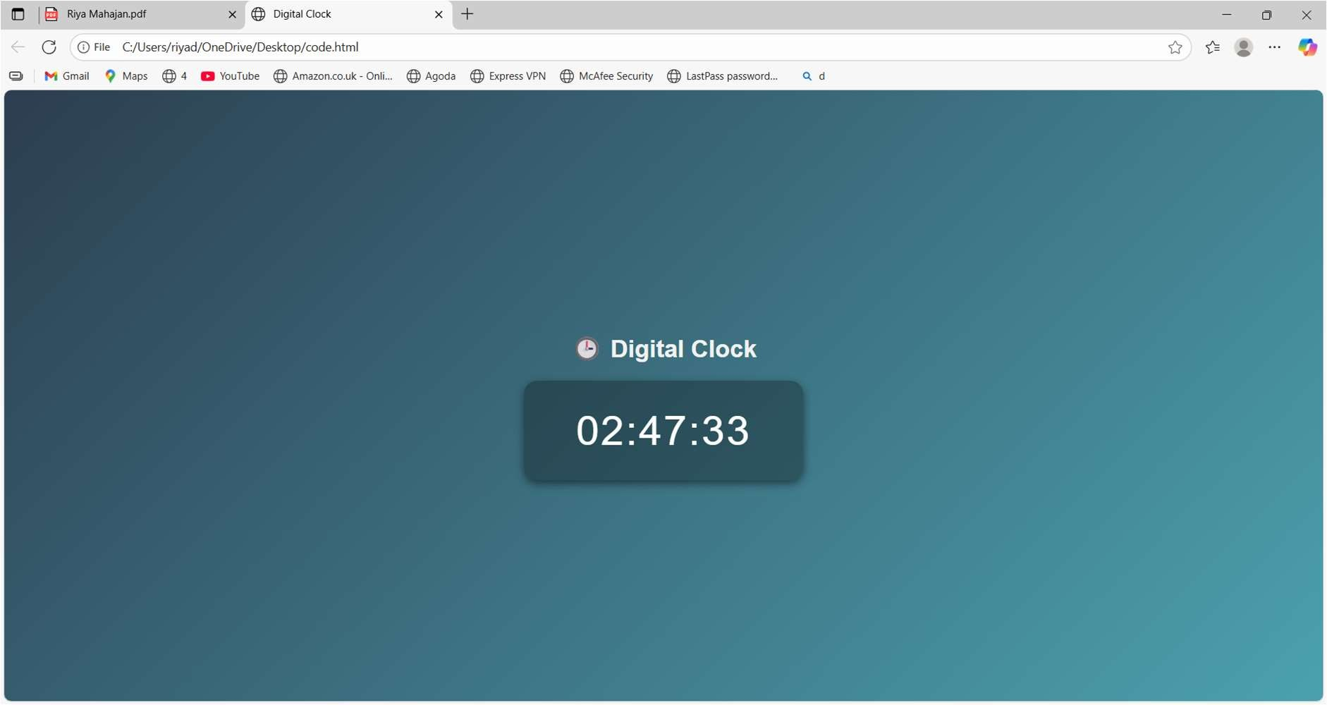
Output:

